

National Secretariat for the

Reduction of Teenage Pregnancy



**CONTEXT**

**IMPLEMENTATION UPDATE**

**AUGUST 2013**

**National Strategy for the reduction of Teenage Pregnancy**

In Sierra Leone, teenage pregnancy is one of the more pervasive problems affecting the health, social, economic and political progress and empowerment of women and girls. The issue to address is alarming and is reflected in the following national statistics: 34% of all pregnancies occur amongst teenage girls (SLDHS 2008), 26% of women age 15-19 have already had a birth (MICS 2010), 40% of maternal death occur as a result of teenage pregnancy (MICS 2010) and the untimely pregnancy of young girls is ranked as the third most common reason for them dropping out of school (UNICEF 2008).

Adolescent pregnancy is dangerous, with serious long-term health consequences for the young mother and the baby. Pregnancy is the leading cause of death for adolescent girls and the youngest girls are particularly at risk. Babies born to adolescent mothers are also at greater risk: adolescent pregnancy is directly associated with premature delivery, stillbirth, fetal distress, birth asphyxia, low birthweight, and miscarriage. Babies born to teen mothers are also far more likely to die than those born to older women. But the impacts of adolescent pregnancy are felt far beyond the walls of the family home. It also has a demonstrable impact on the social and economic development of communities and countries.

Under the leadership of H.E. the President, a multi-sectoral committee was set up in 2012, involving five Ministries as well as key stakeholders (UN-Agencies, NGOs, civil society), to develop a comprehensive strategy. The strategy’s expected outcome is to reduce teenage pregnancy in Sierra Leone by 2015, through integrated and coordinated interventions of all partners. **By 2015, the strategy intends to have reduced the adolescent fertility rate from 122/1000 (MICS4-2010) to 110/1000.**

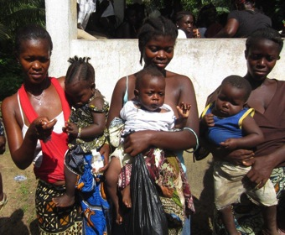

**LAUNCHING OF THE NATIONAL STRATEGY**

On the 13th of May 2013, His Excellency the President officially launched the National Strategy for the Reduction of Teenage Pregnancy. In addition to H.E. the President himself, the ceremony was honored by the presence of Their Excellences the First Ladies of Nigeria and Sierra Leone, the Ministers of Health and Sanitation, of Information and Communication as well as of Social Welfare, Gender and Children’s Affairs. Representatives of the Ministries of Finance and Economic Development, of Education, Science and Technology as well as of Youth Affairs completed the high table.

In total, more than 2 000 people attended the celebration but some key participants can be identified. These include fifty delegates from Nigeria (Spouses of Ministers and State Governors, former Government Ministers and other distinguished guests), Representatives of the Parliamentarians and of the Paramount Chiefs, Religious leaders, Senior officers of Line Ministries, Heads of UN Agencies, donors, representatives of NGO partners and other concerned individuals. Finally, the participants to this important event included representatives from the adolescents and young people (300 out-of-school youths and 600 in-school pupils), key beneficiaries of the National Strategy.

At the Launching ceremony of the National Strategy, on 13 May 2013, His Excellency the President indicated that: “*The Government of Sierra Leone will make all efforts necessary to achieve the ambitious objectives that the National Strategy is setting. (…) This strategy presents a multisectoral approach to empowering adolescents and young people, particularly girls. It involves all key stakeholders and present simple but ambitious solution to Teenage Pregnancy. But more than that, it is a commitment that we make for the younger generations.”*



**COORDINATING MECHANISMS OF THE NATIONAL STRATEGY**

In light of the large spectrum and heterogeneity of partners involved, the implementation of the National Strategy requires close coordination of all the stakeholders, internal communication as well as a detailed Monitoring and Evaluation system in place. A set of coordinating mechanisms were put in place.

**The National Secretariat**

To guarantee daily coordination of the implementation of the Strategy’s activities, the Government of Sierra Leone has approved the creation of the National Secretariat for the Reduction of Teenage Pregnancy. This Secretariat is placed under the authority of the Multisectoral Coordinating Committee (involving all concerned Ministers as well as heads of UN Agencies), which defines its role and prerogatives and to which it reports on a quarterly basis. For day-to-day activities, the Secretariat is placed under the direct supervision of MOHS.

The Secretariat is composed of one National Coordinator, Ms. Patricia A. Bah, who is providing overall supervision and guidance and directly liaises with all stakeholders, and of one Program Adviser, Mr. Philippe Lust-Bianchi, whose responsibility is to assist the coordinator and ensuring the sound implementation of the partners’ activities within the framework of the National Strategy and guidance of the Multisectoral Coordinating Committee.

**The Multisectoral Coordinating Committee**

The Multisectoral Coordinating Committee is the driving force of the National Strategy. Its role is to provide policy guidance and direction, ensure effective inter-sectoral/inter-ministerial communication, support information sharing across all participating partners and monitor the progress of activities undertaken. The MCC also plays a central role for resource mobilization, presenting proposals from partners to donors.

The MCC is composed of the concerned Ministers (MOHS, MSWGCA, MYA, MEST and MLGRD and when relevant, MOFED), heads of UN Agencies, donors, heads of NACSA and NAS as well as a representative of the NGOs. The first meeting of the MCC was held on the 9th of July and was chaired by the Minister of Finance and Economic Development.

**The Multisectoral Coordinating Committee**

The Multisectoral Technical Committee is a forum for all partners to exchange on technical matters. Its role is to provide technical guidance, monitor implementation of activities ensuring harmony and complementarity of interventions. Facilitates sharing of technical information across sectors and all participating organizations. The MTC also develops concrete proposals to be presented to the MCC. The MCC is composed of Ministry focal points, MDAs, UN Agencies, NGOs, Civil Society, Youth Association. The MTC meets monthly and is chaired by the National Secretariat of the Strategy. Three meetings of the MTC were organized so far.

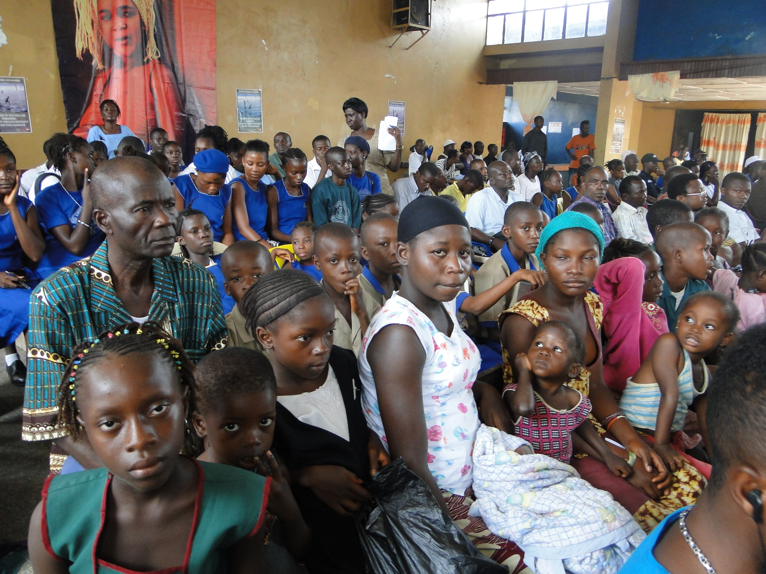

**KEY ACTIVITIES IMPLEMENTED SO FAR**

Further to the launching of the National Strategy, all partners kick started the implementation of targeted activities aiming at reducing the prevalence of Teenage Pregnancy. These cover all the spectrum of sectors highlighted in the Strategy document (Health, Social Protection, Education, Access to Justice, Youth empowerment and Employment, etc.) and include: an ambitious training program on Youth-friendly services for health workers, outreach programs for adolescents and young people, community mobilization and generational dialogues, etc.

The National Secretariat is currently collecting reports from the different partners to be able to provide a picture of the first results. The National Secretariat is however in a position to report on the activities it directly implemented:

* **Rollout of the National Strategy to the Provinces**

The Secretariat and its partners organized the rollout of the Strategy in Bo (11th July), Kenema (13th) and Makeni (15th), with support from UNFPA, WHO and UNICEF. This also gave the opportunity to celebrate the World Population Day, which focused this year on Adolescent Pregnancy as well as to disseminate the Standards on Adolescent and Youth-Friendly Services developed by MOHS and WHO.

The Keynote addresses were given by H.E. the First Lady and by H.E. the Wife of the Vice-President and key national stakeholders participated in the event (including MOHS, MSWGCA, MLGRD, MEST, MOFED) as well as regional authorities (Mayors of Regional Headquarter Towns, Regional Ministers, DMOs and districts officers of Ministries).

The following lessons-learned can be drawn from the celebrations:

* There is strong interest and commitments but also high expectations at regional and district level.
* Regional and district stakeholders are welcoming the multisectoral approach at decentralized level (not only national, but also regions, districts, communities) as they feel this is one of the challenges that prevent them from efficiently implementing their activities.
* Partners highlight strong disparities in development partners’ coverage of the districts and communities. This underlines again the importance of the planned mapping exercise.
* **Development of the Operational Plan**

Under the coordination of the National Secretariat, partners have collectively developed the **Operational Plan** of the National Strategy. They have reviewed the Strategy activities together with their own program and identified the key activities in the Strategy that they are implementing in the next 3-6 months and corresponding sub activities that contribute to the Strategy

The operational Plan reveals the following priorities in the next 3-6 months:

* Capacity-building of health workers, social workers and teachers to provide youth-friendly services and information.
* Outreach campaigns and upgrade of PHUs to provide better SRH services and information to AYP.
* Community mobilization on gender roles, teenage pregnancy and youth empowerment (incl. generational dialogues).
* Enforcement and dissemination of laws through bylaws and sensitization activities (review of policies when necessary).
* Targeted income generated activities together with skills-development trainings.

This exercise was also an opportunity to highlight areas where additional funding will be required. Partners of the National Strategy particularly highlighted the following activities: development of in-service training, income-generating activities, generational dialogues, outreach Programs, coordinated training programs for peer educators, mentoring, role-models, mobilization of boys/men and the support to the curriculum reform.

In light of the situation, the National Secretariat developed a resource mobilization approach as well as templates and tools. These are currently being reviewed.

* **Setting up of an M&E system**

In light of the large spectrum and heterogeneity of partners involved, the implementation of the National Strategy requires close coordination of all the stakeholders through a detailed Monitoring and Evaluation system in place. The Strategy requires a Performance Management System, which would allow measuring the achievements of its outputs. This System must include both a strategic and operational framework for results-based management.

For this purpose, the National Secretariat will recruit two consultants in September:

* One M&E Expert to design an M&E system for effective management of the Strategy and measure achievements (M&E Assessment, M&E plan, budget, data collection framework, training of key actors, lessons-learned…)
* One M&E Officer to participate in the design of the M&E system and support its implementation (data collection/compilation, quarterly reports, annual review, national validation meeting, capacity building)
* **Design of a Behavior and Social Change Strategy for the reduction of Teenage Pregnancy**

In the multiplicity of causes of teenage pregnancy, strong emphasis must be put on social norms, which are key drivers of this problem. Society (including girls themselves) views it as normal – even expected and desirable – that adolescents become pregnant at an early age. To address these social norms, it is important that partners of the strategy use all channels available (media, community mobilization, entertainment event, etc.) to communicate messages and provide information to the general public and to adolescent and young people in particular.

Further to consultations, the Secretariat developed terms of reference for one consultant to develop a national strategy that will guide activities aimed at creating behavior change in all sectors covered by the National Strategy. The consultant will be recruited in September, his/her deliverables are as follows:

* Development of draft strategy to be presented with MTC
* Integration of comments/suggestions by partners
* Validated strategy by MCC
* Implementation and M&E plan